**SECTION A-46 MARKS**

**Attempt** all **questions in this section.**

1. has half-life of **20** minutes.
2. (i). Plot a graph of percentage remaining against time. (01½ marks)

………………………………………………………………………………………………………………………………………………………………………………………………………………………………………………………………………………………………………………………………………………………………………………………………………………………………………………………………………………………………………………………………………………………………………………………………………………………………………………………………………………………………………………………………………………

………………………………………………………………………………………………………………………………………………………………………………………………………………………………………………

(ii).What percentage of would remain after **70** minutes? (02½ marks)

………………………………………………………………………………………………………………………………………………………………………………………………………………………………………………………………………………………………………………………………………………………………………………………………………………………………………………………………………………………………………………………………………………………………………………………………………………………………………………………………………………………………………………………………………………………………………………………………………………………………………………………………………………………………………………………………………………………………………………………………………………………………………………………………………………………………………………………………………………………………………………………………………………………………………………

1. Write nuclear equations for the following charges: (@01 mark)
2. When absorbs a colliding proton, the product disintegrates into two exactly similar fragments.

…………………………………………………………………………………………………………………………………………………………………………………………………………………………………………

1. When emits six alpha particle and four beta particles in its natural decay.

…………………………………………………………………………………………………………………………………………………………………………………………………………………………………………

1. Write the electronic configuration of Titanium. (0½ mark)

………………………………………………………………………………………………………………………

1. State the possible oxidation state of Titanium. (01½ marks)

………………………………………………………………………………………………………………………

1. For each of the oxidation states in (b) above, Write the formula of the compound in which Titanium exhibits the oxidation state. (02½ marks)

………………………………………………………………………………………………………………………………………………………………………………………………………………………………………………………………………………………………………………………………………………………………………

1. Complete each of the following equations and name the main organic product. (@01 mark)
2. (CH3COO)2Pb  ………………………………………………………………

……………………………………………………………….

1. CH3COCH3  ………………………………………………………………
2.   ………………………………………………………………
3. The cell convention is given below:

Pt(s)/Fe2+(aq),Fe3+(aq)//MnO4-(aq),Mn2+(aq),H+(aq)/Pt(s)

1. Write equation for all the half-cell reactions at: (@01 mark)
2. Anode:

…………………………………………………………………………………………………………………………………………………………………………………………………………………………………………

1. Cathode:

…………………………………………………………………………………………………………………………………………………………………………………………………………………………………………

1. Write the overall equation for the cell reaction. (01½ marks)

………………………………………………………………………………………………………………………………………………………………………………………………………………………………………………

1. The electrode potential for the system Fe2+(aq)/Fe3+(aq) and Mn2+(aq)/MnO4-(aq) are +0.76V and -1.51V respectively.
2. Calculate the standard free energy of the cell. (01½ marks)

………………………………………………………………………………………………………………………………………………………………………………………………………………………………………………………………………………………………………………………………………………………………………………………………………………………………………………………………………………………………………………………………………………………………………………………………………………………………………………………………………………………………………………………………………………

1. What is the significance of the standard free energy? (01 mark)

……………………………………………………………………………………………………………………………………………………………………………………………………………………………………

1. Write an equation for dissolution of each of the following compounds in water. State whether the resultant solution is neutral, acidic or basic [alkaline]. (@02 marks)
2. Sodium sulphide.

………………………………………………………………………………………………………………………………………………………………………………………………………………………………………………………………………………………………………………………………………………………………………

1. Ammonium methanoate.

………………………………………………………………………………………………………………………………………………………………………………………………………………………………………………………………………………………………………………………………………………………………………

1. Sodium benzoate.

………………………………………………………………………………………………………………………………………………………………………………………………………………………………………………………………………………………………………………………………………………………………………

1. Phenylammonium chloride.

………………………………………………………………………………………………………………………………………………………………………………………………………………………………………………………………………………………………………………………………………………………………………

1. Name a reagent that can be used to differentiate between each of the following pairs of substances. In each case state what would be observed when the reagent is treated with each member of the pair. (@03 marks)
2. HCOONa(aq) and Na2C2O4(aq)

Reagent:

………………………………………………………………………………………………………………………………………………………………………………………………………………………………………………

Observation (s):

………………………………………………………………………………………………………………………………………………………………………………………………………………………………………………

1. H2S and SO2

Reagent:

………………………………………………………………………………………………………………………………………………………………………………………………………………………………………………

Observation (s):

………………………………………………………………………………………………………………………………………………………………………………………………………………………………………………

1. 

Reagent:

………………………………………………………………………………………………………………………………………………………………………………………………………………………………………………

Observation (s):

………………………………………………………………………………………………………………………………………………………………………………………………………………………………………………………………………………………………………………………………………………………………………

1. State what is observed when the following substances are separately mixed together. (@0½ mark)
2. Ethanoic acid and neutral iron (III) chloride solution.

……………………………………………………………………………………………………………………… ………………………………………………………………………………………………………………………

1. Methanoic acid and hot copper (II) sulphate solution in the presence of sodium hydroxide solution.

………………………………………………………………………………………………………………………

1. Benzene diazonium chloride and naphthalene-2-ol in the presence of sodium hydroxide solution.

………………………………………………………………………………………………………………………

1. Methanol and benzoic acid in the presence of concentrated sulphuric acid.

………………………………………………………………………………………………………………………

1. Ethanol and phosphorous pentachloride.

………………………………………………………………………………………………………………………

1. Potassium tetraoxalate has the formula H2C2O4.KHC2O4.xH2O. 1.9g of Potassium tetraoxalate was neutralized by 22.7cm3 of 1M sodium hydroxide solution using phenolphthalene as indicator. Determine the value of x.

………………………………………………………………………………………………………………………………………………………………………………………………………………………………………………………………………………………………………………………………………………………………………………………………………………………………………………………………………………………………………………………………………………………………………………………………………………………………………………………………………………………………………………………………………………………………………………………………………………………………………………………………………………………………………………………………………………………………………………………………………………………………………………………………………………………………………………………………………………………………………………………………………………………………………………

1. 0.01M solution of sodium chloride is 92.5% ionized at a temperature of 18ᵒC.Calculate the osmotic pressure of the solution in mmHg. [Universal gas constant, R = 0.082at/mol/k]

………………………………………………………………………………………………………………………………………………………………………………………………………………………………………………………………………………………………………………………………………………………………………………………………………………………………………………………………………………………………………………………………………………………………………………………………………………………………………………………………………………………………………………………………………………

1. 25.0cm3 of dimethylammine solution was titrated with 0.1M hydrochloric acid. Sketch a graph to show the variation of pH of the resulting solution with the volume of hydrochloric acid.

………………………………………………………………………………………………………………………………………………………………………………………………………………………………………………………………………………………………………………………………………………………………………………………………………………………………………………………………………………………………………………………………………………………………………………………………………………………………………………………………………………………………………………………………………………………………………………………………………………………………………………………………………………………………………………………………………………………………………………………………………………………………………………………………………………………………………………………………………………………………………………………………………………………………………………

1. 0.1m hydrochloric acid was added to 25.0cm3 of sodium carbonate solution. Sketch a graph to show the variation of pH of the resultant solution with the volume of hydrochloric acid added. Explain the graph shape.

………………………………………………………………………………………………………………………………………………………………………………………………………………………………………………………………………………………………………………………………………………………………………………………………………………………………………………………………………………………………………………………………………………………………………………………………………………………………………………………………………………………………………………………………………………………………………………………………………………………………………………………………………………………………………………………………………………………………………………………………………………………………………………………………………………………………………………………………………………………………………………………………………………………………………………

………………………………………………………………………………………………………………………………………………………………………………………………………………………………………………………………………………………………………………………………………………………………………………………………………………………………………………………………………………………………

**SECTION B-54 MARKS**

**Attempt** ANY **SIX questions in this section.**

1. When red lead, Pb3O4 was reacted with nitric acid, a solid was formed. Write equation for the reaction. (01½ marks)

………………………………………………………………………………………………………………………………………………………………………………………………………………………………………………

1. The mixture from (a) above was filtered and the residue warmed with concentrated hydrochloric acid.
2. State what was observed? Explain your answer. (01½ marks)

…………………………………………………………………………………………………………………………………………………………………………………………………………………………………………………………………………………………………………………………………………………………………………………………………………………………………………………………………………

1. Write the equation (s) for the reaction. (03 marks)

…………………………………………………………………………………………………………………………………………………………………………………………………………………………………………………………………………………………………………………………………………………………………………………………………………………………………………………………………………

1. The filtrate from (a) above was divided in two portions.
2. To the first portion was added aqueous potassium iodide solution. State what was observed and write the equation for the reaction. (02 marks)

……………………………………………………………………………………………………………………………………………………………………………………………………………………………………

1. The second portion was evaporated to dryness and heated strongly. Explain what was observed and write the equation for the reaction that took place. (02½ marks)

…………………………………………………………………………………………………………………………………………………………………………………………………………………………………………………………………………………………………………………………………………………………………………………………………………………………………………………………………………

1. Rubber is a natural polymer whose monomer is 2-methylbutan-1,3-diene. Write the structure of: (@01 mark)
2. The monomer of rubber.

……………………………………………………………………………………………………………………………………………………………………………………………………………………………………

1. The structural formula of rubber.

……………………………………………………………………………………………………………………………………………………………………………………………………………………………………

1. (i) Briefly describe how rubber is vulcanized. (01½ marks)

……………………………………………………………………………………………………………………………………………………………………………………………………………………………………………..

1. Name one substance that is added to prolong the life of rubber. (01 mark)

……………………………………………………………………………………………………………………………………………………………………………………………………………………………………………..

1. Name any one other natural polymer. (0½ mark)

………………………………………………………………………………………………………………………………………………………………………………………………………………………………………………

1. In the extraction of copper from its ores, the ores are first concentrated and then roasted in air. The roasted material is then mixed with silica and heated with hot air in a blast furnace producing copper.
2. Write the name and formula of one ore from which copper can be extracted. (01 mark)

………………………………………………………………………………………………………………………………………………………………………………………………………………………………………………

1. Describe the process by which the ore named in (a) above can be concentrated.

………………………………………………………………………………………………………………………………………………………………………………………………………………………………………………………………………………………………………………………………………………………………………………………………………………………………………………………………………………………………………………………………………………………………………………………………………………………………………………………………………………………………………………………………………………………………………………………………………………………………………………………………………………………………………………………………………………………………………………………………………………………………………………………………………………………………………………………………………………………………………………………………………………………………………………

1. Write equation for the reaction that took place when the ore is roasted in air. (01½ marks)

……………………………………………………………………………………………………………………………………………………………………………………………………………………………………………..

1. Write equation for the reactions that lead to the formation of copper in the blast furnace. (02 marks)

……………………………………………………………………………………………………………………………………………………………………………………………………………………………………………..

1. Complete the following equations and in each case write a mechanism for the reaction.
2. ……………………………...........................................

………………………………………………………………………………………………………………………………………………………………………………………………………………………………………………………………………………………………………………………………………………………………………………………………………………………………………………………………………………………………………………………………………………………………………………………………………………………………………………………………………………………………………………………………………………………………………………………………………………………………………………………………………………………………………………………………………………………………………………………………………………………………………………………………………………………………………………………………………………………………………………………………………………………………………………

………………………………………………………………………………………………………………………………………………………………………………………………………………………………………………………………………………………………………………………………………………………………………………………………………………………………………………………………………………………………………………………………………………………………………………………………………………………

1.  …………………………………………..

………………………………………………………………………………………………………………………………………………………………………………………………………………………………………………………………………………………………………………………………………………………………………………………………………………………………………………………………………………………………………………………………………………………………………………………………………………………………………………………………………………………………………………………………………………………………………………………………………………………………………………………………………………………………………………………………………………………………………………………………………………………………………………………………………………………………………………………………………………………………………………………………………………………………………………

………………………………………………………………………………………………………………………………………………………………………………………………………………………………………………………………………………………………………………………………………………………………………………………………………………………………………………………………………………………………………………………………………………………………………………………………………………………

1. ……………………………………

………………………………………………………………………………………………………………………………………………………………………………………………………………………………………………………………………………………………………………………………………………………………………………………………………………………………………………………………………………………………………………………………………………………………………………………………………………………………………………………………………………………………………………………………………………………………………………………………………………………………………………………………………………………………………………………………………………………………………………………………………………………………………………………………………………………………………………………………………………………………………………………………………………………………………………

………………………………………………………………………………………………………………………………………………………………………………………………………………………………………………………………………………………………………………………………………………………………………………………………………………………………………………………………………………………………………………………………………………………………………………………………………………………

1. **1 mole** of hydrogen iodide gas was introduced in to a container of volume **20litre**s at room temperature.
2. Calculate the pressure of the gas, assuming ideal behaviors. [1 mole of an ideal gas occupies 22.4 litres under standard condition]

………………………………………………………………………………………………………………………………………………………………………………………………………………………………………………………………………………………………………………………………………………………………………………………………………………………………………………………………………………………………………………………………………………………………………………………………………………………………………………………………………………………………………………………………………………………………………………………………………………………………………………………………………………………………………………………………………………………………………………………………………………………………………………………………………………………………………………………………………………………………………………………………………………………………………………

1. The sample of hydrogen iodide, considered above was raised to a temperature of **300ᵒC** and it partially decomposed in to hydrogen and iodine gases. At equilibrium **0.1** mole of iodine was found to be present.
2. Write an equation for the decomposition. (01 mark)

……………………………………………………………………………………………………………………………………………………………………………………………………………………………………

1. Calculate the pressure of equilibrium mixtures at **300ᵒC**, assuming no change in volume.

………………………………………………………………………………………………………………………………………………………………………………………………………………………………………………………………………………………………………………………………………………………………………………………………………………………………………………………………………………………………………………………………………………………………………………………………………………………………………………………………………………………………………………………………………………………………………………………………………………………………………………………………………………………………………………………………………………………………………………………………………………………………………………………………………

1. Calculate the equilibrium constant at 300ᵒC.

………………………………………………………………………………………………………………………………………………………………………………………………………………………………………………………………………………………………………………………………………………………………………………………………………………………………………………………………………………………………………………………………………………………………………………………………………………………………………………………………………………………………………………………………………………………………………………………………………………………………………………………………………………………………………………………………………………………………………………………………………………………………………………………………………………………………………………………………………………………………………………………………………………………………………………………………………………………………………….

1. Explain giving reasons how you expect the equilibrium constant to change with temperature, ∆Hᵒf[HI] = +26.5kg/mol.

………………………………………………………………………………………………………………………………………………………………………………………………………………………………………………………………………………………………………………………………………………………………………………………………………………………………………………………………………………………………………………………………………………………………………………………………………………………………………………………………………………………………………………………………………………………………………………………………………………………………………………………………………………………………………………………………………………………………………………………………

1. Aminobenzene reacts quantatively with bromine that is obtained by electrolysis of concentrated sodium bromide solution. 25.0cm3 of 0.01M aqueous aminobenzene was mixed with 25.0cm3 of 1M potassium bromide solution and electrolyzed at a current of 0.1A. The first permanent bromine colour was noticed after 1,448seconds and the electrolysis was stopped.
2. Calculate:
3. The number of moles of bromine generated during electrolysis. [1F = 96,500C]

……………………………………………………………………………………………………………………………………………………………………………………………………………………………………………………………………………………………………………………………………………………………………………………………………………………………………………………………………………………………………………………………………………………………………………………………………………………………………………………………………………………………………………………………………………………………………………………………………………………………………………………………………………………………………………………………………………………………………………………………… ……………………………………………………………………………………………..

1. The number of moles of bromine that reacted with 1 mole of aminobenzene.

……………………………………………………………………………………………………………………………………………………………………………………………………………………………………………………………………………………………………………………………………………………………………………………………………………………………………………………………………………………………………………………………………………………………………………………………………………………………………………………………………………………………………………………………………………………………………………………………………………………………………………………………………………………………………………………………………………………………………………………………… ……………………………………………………………………………………………

1. Write an equation for the reaction between aminobenzene and bromine.

………………………………………………………………………………………………………………………………………………………………………………………………………………………………………………………………………………………………………………………………………………………………………

1. Powdered magnesium hydroxide was shaken with water at room temperature to form a saturated solution. The mixture was filtered and 100.0cm3 of the filtrate required 6.40cm3 of 0.01M hydrochloric acid for complete reaction.
2. Write an expression for the solubility product of magnesium hydroxide and state its unit.

……………………………………………………………………………………………………………………………………………………………………………………………………………………………………………… ………………………………………………………………………………………………………………………

1. Calculate the solubility product of magnesium hydroxide at room temperature.

……………………………………………………………………………………………………………………………………………………………………………………………………………………………………………………………………………………………………………………………………………………………………………………………………………………………………………………………………………………………………………………………………………………………………………………………………………………………………………………………………………………………………………………………………………………………………………………………………………………………………………………………………………………………………………………………………………………………………………………………… ………………………………………………………………………………………………………………………

1. Explain the effect, if any on the solubility of magnesium hydroxide if the following substances were added separately:
2. Sodium hydroxide solution.

……………………………………………………………………………………………………………………………………………………………………………………………………………………………………………………………………………………………………………………………………………………………………………………………………………………………………………………………………………………………………………………………………………………………………………………………………………………………………………………………………………………………………………………………………………………………………………………………………………………………………………………………………………………………………………………………………………………………………………………………………………………………………………………………………… ………………………………………………………………………………………………………………

1. A compound which forms a stable complex with magnesium ions.

……………………………………………………………………………………………………………………………………………………………………………………………………………………………………………………………………………………………………………………………………………………………………………………………………………………………………………………………………………………………………………………………………………………………………………………………………………………………………………………………………………………………………………………………………………………………………………………………………………………………………………………………………………………………………………………………………………………

1. Aluminium nitrate solution. [Ksp for Al(OH)3 = 1.0 X 10-32]

……………………………………………………………………………………………………………………………………………………………………………………………………………………………………………………………………………………………………………………………………………………………………………………………………………………………………………………………………………………………………………………………………………………………………………………………………………………………………………………………………………………………………………………………………………………………………………………………………………………………………………………………………………………………………………………………………………………

1. The table below shows the temperature rise when various volumes of 2M sulphuric acid were added to 60.0cm3 of about 2M sodium hydroxide solution and in each case the total volume made up to 120.0cm3 with water.

|  |  |  |  |  |  |  |
| --- | --- | --- | --- | --- | --- | --- |
| Experiments | 1 | 2 | 3 | 4 | 5 | 6 |
| Volume of NaOH /cm3 | 60 | 60 | 60 | 60 | 60 | 60 |
| Volume of 2M H2SO4 /cm3 | 5 | 10 | 20 | 25 | 30 | 40 |
| Volume of water /cm3 | 55 | 50 | 40 | 35 | 30 | 20 |
| Temperature rise [ᵒC] | 4.8 | 6.9 | 9.1 | 10.1 | 10.1 | 10.0 |

1. Plot a graph of temperature rise against volume of sulphuric acid added.



1. From the graph determine the highest temperature rise.

……………………………………………………………………………………………………………………………………………………………………………………………………………………………………………………………………………………………………………………………………………………………………………………………………………………………………………………………………………………………………………………………………………………………………………………………………………………………………………………………………………………………………………………………………………………………………………………………………………………………………………………………………………………………………………………………………………………………………………………………… ……………………………………………………………………………………………………………………..

1. Calculate the heat of neutralization of sulphuric acid and give its unit. [Density of solution = 1kg/dm3 & SHC of H2O = 4.2kJ/kg/K]

……………………………………………………………………………………………………………………………………………………………………………………………………………………………………………………………………………………………………………………………………………………………………………………………………………………………………………………………………………………………………………………………………………………………………………………………………………………………………………………………………………………………………………………………………………………………………………………………………………………………………………………………………………………………………………………………………………………………………………………………… ………………………………………………………………………………………………………………………

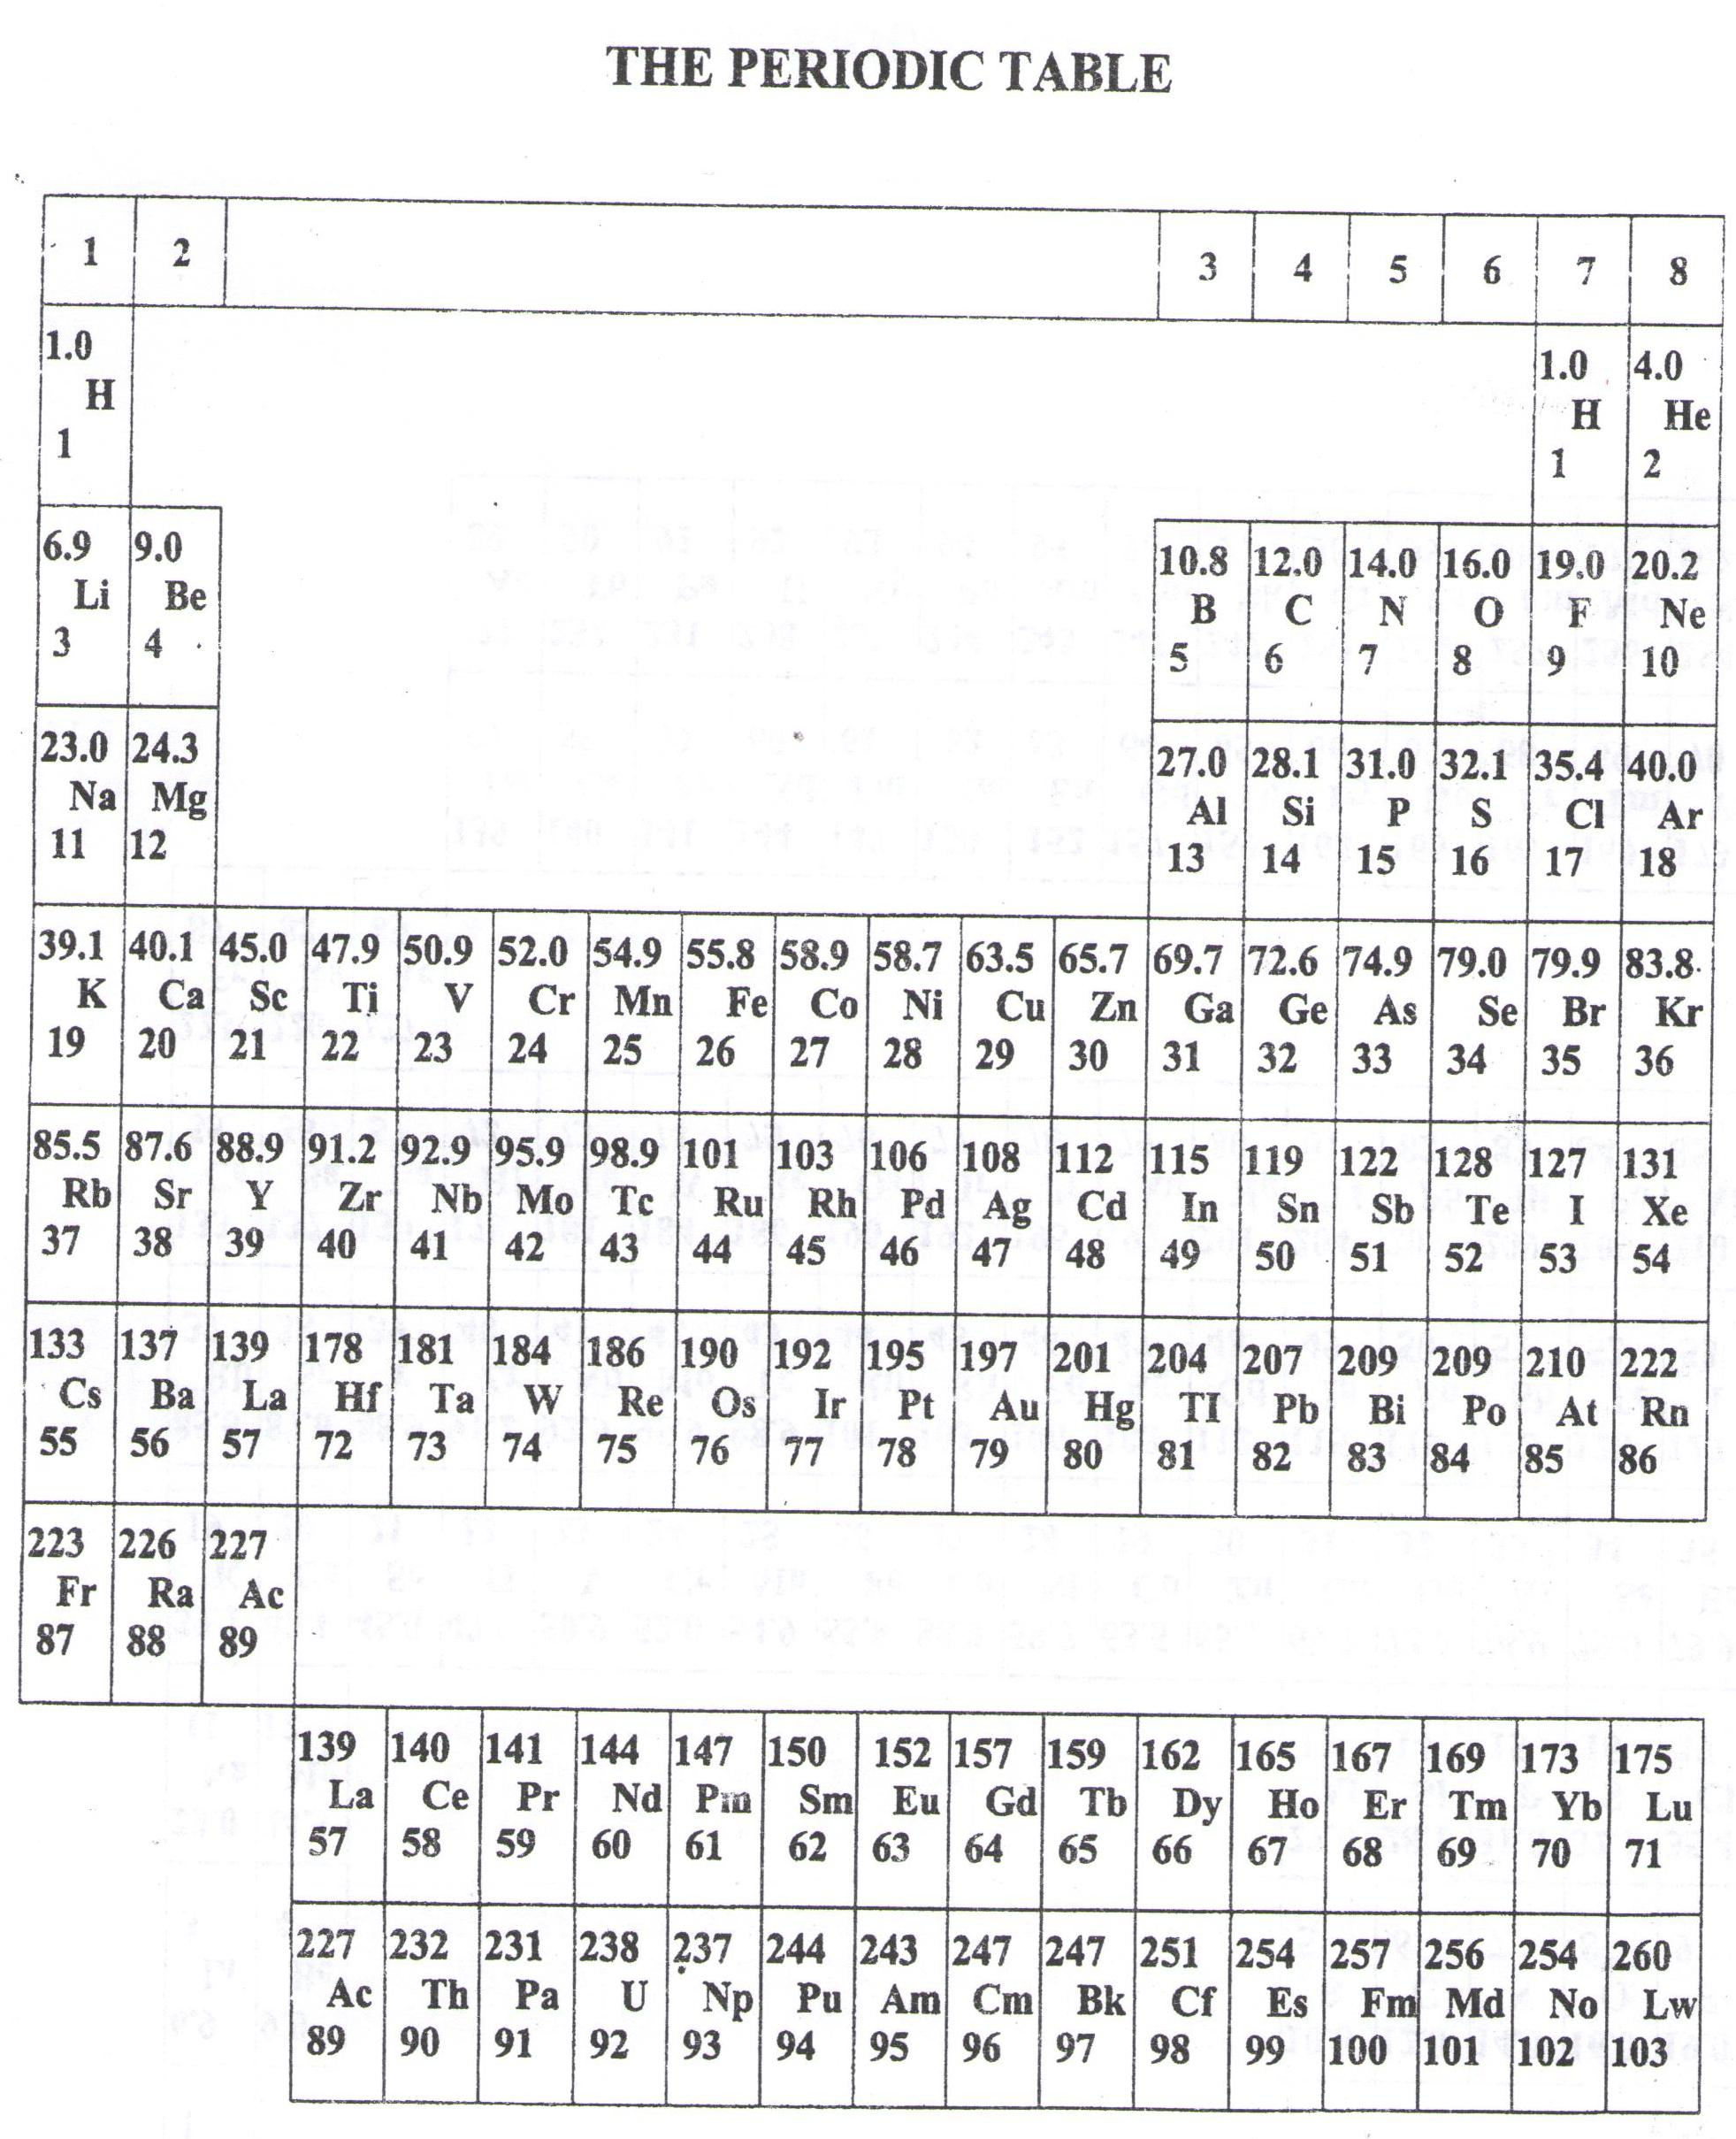

* ===END===

WELCOME TO SENIOR SIX, YEAR 2023

This is the last page of the printed paper, Page 22